UNSPECIFIED in Owing Organization_Leader_1:

SELECT LEV.LVL1_ORGLEAD_INTRANETID AS L1Owning_Organization_Leader1,Count(distinct SRC.NAME)

FROM png_mdsdb.pg_mega_pgb_application_rita_final SRC

LEFT JOIN png_mdsdb.pg_mega_pgv_app_responsible_org_person_final SRC1 ON SRC.NAME=SRC1.app_hexid AND SRC.sourceinstance=SRC1.sourceinstance

LEFT JOIN

(

Select DISTINCT a.sourceinstance,a.LVL3_ORG_HEX,a.LVL2_ORG_HEX,a.LVL1_ORG_HEX,a.LVL0_ORG_HEX,a.LVL1_ORG_NAME,a.LVL2_ORG_NAME,a.LVL3_ORG_NAME,

a.LVL1_ORGLEAD_INTRANETID,a.LVL2_ORGLEAD_INTRANETID,a.LVL3_ORGLEAD_INTRANETID

FROM png_mdsdb.pg_mega_pgv_org_itam_gbs_final a

WHERE a.cdctype<>'D'

) LEV ON

(SRC1.responsible_org_unit_hexid=LEV.LVL3_ORG_HEX OR SRC1.responsible_org_unit_hexid=LEV.LVL2_ORG_HEX

OR SRC1.responsible_org_unit_hexid=LEV.LVL1_ORG_HEX OR SRC1.responsible_org_unit_hexid=LEV.LVL0_ORG_HEX)

AND SRC1.sourceinstance=LEV.sourceinstance

WHERE SRC1.pg_development_org='Y' AND SRC1.app_hexid IS NOT NULL AND SRC.cdctype<>'D' AND SRC1.cdctype<>'D'

AND SRC.APPLICATION_NATURE IN ('Generic','XOApplication','XOPlatform','Platform')

AND SRC.LIFE_CYCLE_STATUS IN ('Design/Build','Discovery/Requ.','Exception','Leverage/Optimize','Launch/Deploy',

'Qualify/Deliver','Retired','Sunset','Undecided','UNSPECIFIED')

group by 1;

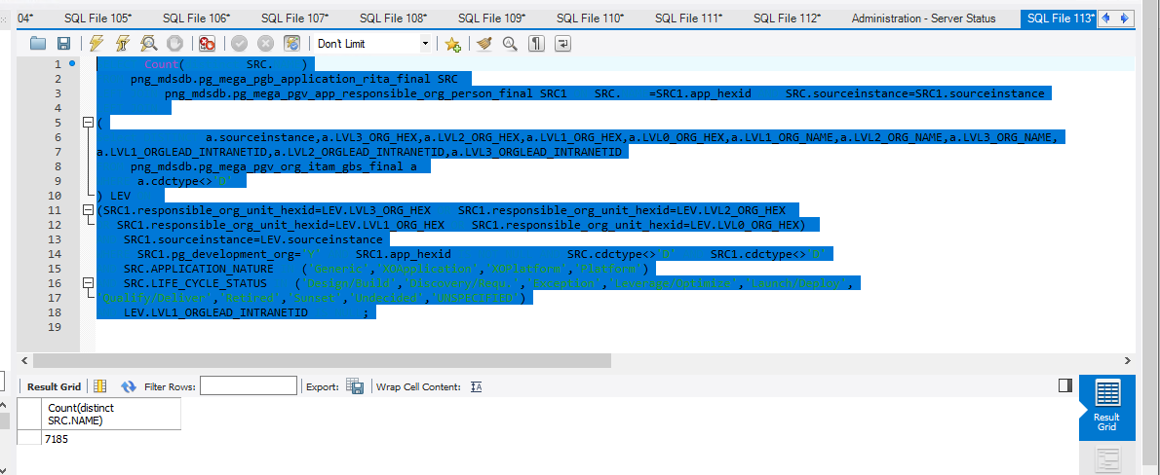

PG_FDA_Regulation:

Select a.PG_FDA_REGULATED,Count(1) as CNT

FROM png_mdsdb.pg_mega_pgb_application_rita_final a

where a.APPLICATION_NATURE IN ('Generic','XOApplication','XOPlatform','Platform')

AND a.LIFE_CYCLE_STATUS IN ('Design/Build','Discovery/Requ.','Exception','Leverage/Optimize','Launch/Deploy',

'Qualify/Deliver','Retired','Sunset','Undecided','UNSPECIFIED')

AND a.cdctype<>'D'

group by 1;

